This time is no
exception, the last post made me want to investigate further the notion of
hypothesis testing and multiple comparisons, especially in a Bayesian framework.
So here we go again.
This post assumes that you’ve read the earlier posts.
Let’s quickly create our dataset following the same methodology as the last two
times, with the important exception that we’re going to focus on only the 3
fastest runners. Everything I’m going to do is extensible beyond that, but for
simplicity sake we’ll limit ourselves to just three runners. We’ll load the
required packages (suppressing the chatty load process) and create our dataset,
this time named best3 to reflect the fact we’ve reduced ourselves down to the
3 runners with the fastest mean time, Usain Bolt, Asafa Powell, and Yohan
Blake. So we have a tibble with 273 rows with the runner’s name and how fast
they ran.
library(rvest)
library(readr)
library(tidyverse)
library(ggstatsplot)
library(jmv)
library(BayesFactor)
library(gtools)
library(kableExtra)

male_100_html <- read_html("http://www.alltime-athletics.com/m_100ok.htm")
male_100_pres <- male_100_html %>%
html_nodes(xpath = "//pre")
male_100_htext <- male_100_pres %>%
html_text()
male_100_htext <- male_100_htext[[1]]

male_100 <- read_fwf(male_100_htext, skip = 1, n_max = 3178,
col_types = cols(.default = col_character()),
col_positions = fwf_positions(
c(1, 16, 27, 35, 66, 74, 86, 93, 123),
c(15, 26, 34, 65, 73, 85, 92, 122, 132)
))

best3 <- male_100 %>%
select(X2, X4) %>%
transmute(timing = X2, runner = X4) %>%
mutate(timing = gsub("A", "", timing),
timing = as.numeric(timing)) %>%
filter(runner %in% c("Usain Bolt", "Asafa Powell", "Yohan Blake")) %>%
mutate_if(is.character, as.factor) %>%
droplevels
best3$runner <- fct_reorder(best3$runner, best3$timing)
best3
## # A tibble: 273 x 2
## timing runner
##
## 1 9.58 Usain Bolt
## 2 9.63 Usain Bolt
## 3 9.69 Usain Bolt
## 4 9.69 Yohan Blake
## 5 9.72 Usain Bolt
## 6 9.72 Asafa Powell
## 7 9.74 Asafa Powell
## 8 9.75 Yohan Blake
## 9 9.75 Yohan Blake
## 10 9.76 Usain Bolt
## # … with 263 more rows

The frequentist and multiple comparisons
Last time I chose to look at both parametric and non parametric versions of the
oneway analysis of variance. For brevity’s sake this time I am only going to run
the parametric version so I can focus on Bayesian methods in a later section.
Once again I’m going to use ggstatsplot::ggbetweenstats to combine a whole
bunch of processes that you could also do in base R. The difference is
ggbetweenstats will quickly and efficiently give us not only the tests we need
but let us visualize the data at the same time. We’ll run the required omnibuds F
test to determine whether we can reject the null h₀ that all the runners
have the same mean time. Which is the required first step in nhst when you
have more than two factor levels in your dependent variable. At the same time
we’ll use the parameters pairwise.comparisons = TRUE and pairwise.display = "all" to display graphically our ability to reject the h₀ that all of the
three possible pairings are different. This is in fact actually what we are most
likely interested in for our research. Just for completeness we’ll follow-up
with the base command pairwise.t.test to show the pairwise comparisons.
ggbetweenstats(data = best3,
x = runner,
y = timing,
type = "p",
var.equal = TRUE,
pairwise.comparisons = TRUE,
pairwise.display = "all",
partial = FALSE,
effsize.type = "unbiased",
point.jitter.height = 0,
messages = FALSE
)

pairwise.t.test( x = best3$timing, # outcome variable
g = best3$runner, # grouping variable
p.adjust.method = "holm" # which correction to use?
)
##
## Pairwise comparisons using t tests with pooled SD
##
## data: best3$timing and best3$runner
##
## Usain Bolt Asafa Powell
## Asafa Powell 0.0114 -
## Yohan Blake 0.0051 0.3130
##
## P value adjustment method: holm
You’ve no doubt noticed that holm appears in both versions of the output.
And that’s where we want to focus for now. The Holm method or
correction is one
of many (and by many I do mean many) ways of correcting for the fact
that as we make more and more comparisons we increase the chances that we’ll
reject the null when we shouldn’t.

Key take-aways
Whole books can and have been written just on the issue of multiple comparisons
or simultaneous inference so I’m not going to try and summarize it all in one
little blog post. I will however, for the impatient reader, summarize a few key
things:
- Planned versus unplanned comparisons matter in principle. In the literature
you’ll see a clear distinction between making comparisons based upon clear
hypothesis you’ve specified a prior versus things done post hoc. You are traditionally
granted far more leeway if you’ve specified a small number of contrasts of
interest in advance versus entered into a fishing expedition after the data
are collected. Note that the math doesn’t change.
- The quantity of comparisons matters a great deal. Every additional pairwise
comparison increases your risk of making a Type I error (rejecting h₀
when you shouldn’t). From a frequentist perspective this is very bad since
the entire methodology is based upon statements about controlling for type I
errors.
- Being more conservative about controlling against Type I error comes at the
cost of risking more type II errors, failing to reject h₀ when you
should.
- In principle there are now two distinct approaches to multiple comparisons,
the traditional Family Wise Error
Rate approach which
you’ll see in base R with names like "holm", "hochberg", "hommel", "bonferroni". Then there are relatively newer methods such as “BH”
(Benjamini & Hochberg (1995)), and “BY” (Benjamini & Yekutieli (2001)) which
control for False Discovery
Rate.
Okay enough theory, let’s use our current data about the best 3 runners and
see what happens across a selection of these methods.

What does that look like with our data
First off, we need to get the paired comparisons in some useful format like a
data frame that we can work with. Enter the jmv package. It has an ANOVA
(note the capitalization) function that we can make use of:
jmv::ANOVA(formula = timing ~ runner,
data=best3,
postHoc = ~runner,
postHocCorr = "none")
##
## ANOVA
##
## ANOVA
## ──────────────────────────────────────────────────────────────────────
## Sum of Squares df Mean Square F p
## ──────────────────────────────────────────────────────────────────────
## runner 0.105 2 0.05250 5.81 0.003
## Residuals 2.440 270 0.00904
## ──────────────────────────────────────────────────────────────────────
##
##
## POST HOC TESTS
##
## Post Hoc Comparisons - runner
## ───────────────────────────────────────────────────────────────────────────────────────────
## runner runner Mean Difference SE df t p
## ───────────────────────────────────────────────────────────────────────────────────────────
## Usain Bolt - Asafa Powell -0.0384 0.0138 270 -2.79 0.006
## - Yohan Blake -0.0533 0.0168 270 -3.17 0.002
## Asafa Powell - Yohan Blake -0.0149 0.0148 270 -1.01 0.313
## ───────────────────────────────────────────────────────────────────────────────────────────
Very nice looking, but all I really want is the post hoc section and I want it
as a dataframe not in pretty printed format. Turns out
anovaresults$postHoc[[1]]$asDF will give me that.
anovaresults <- ANOVA(formula = timing ~ runner,
data=best3,
postHoc = ~runner,
postHocCorr = "none")
paired_results <- anovaresults$postHoc[[1]]$asDF
paired_results
## runner1 sep runner2 md se df t
## 1 Usain Bolt - Asafa Powell -0.03840376 0.01378435 270 -2.786039
## 2 Usain Bolt - Yohan Blake -0.05334628 0.01682400 270 -3.170844
## 3 Asafa Powell - Yohan Blake -0.01494253 0.01478285 270 -1.010802
## pnone
## 1 0.005713819
## 2 0.001695214
## 3 0.313016247
Armed with that I can proceed to clean it up a bit and do some relabeling…
paired_results <- paired_results %>%
select(-df) %>%
mutate(Pair = str_c(runner1,sep,runner2)) %>%
rename(meandif = md, stderr = se, tvalue = t) %>%
mutate_at(vars(meandif, stderr, tvalue), round, 3) %>%
select(Pair, meandif, stderr, tvalue, pnone)
paired_results
## Pair meandif stderr tvalue pnone
## 1 Usain Bolt-Asafa Powell -0.038 0.014 -2.786 0.005713819
## 2 Usain Bolt-Yohan Blake -0.053 0.017 -3.171 0.001695214
## 3 Asafa Powell-Yohan Blake -0.015 0.015 -1.011 0.313016247
Pair is self-explanatory and pnone contains the unadjusted probability of
the t-test for that pairing. What we want to do next is to append the
results for the various adjustment methods onto paired_results.
p.adjust.methods contains a vector with the names we have to choose from.
Since we already have the value for none let’s leave that out, and since
fdr and BH are identical let’s remove fdr. Armed with our list of
methods we’d like to try we can use sapply to iterate through our uncorrected
p values and produce a nice matrix with rounded values and store them in
p.adj.
p.adjust.methods
## [1] "holm" "hochberg" "hommel" "bonferroni" "BH"
## [6] "BY" "fdr" "none"
p.adjust.M <- p.adjust.methods[p.adjust.methods %in% c("bonferroni",
"holm",
"hochberg",
"hommel",
"BH",
"BY")]
p.adj <- sapply(p.adjust.M,
function(meth) round(p.adjust(paired_results$pnone, meth), 3))
p.adj
## holm hochberg hommel bonferroni BH BY
## [1,] 0.011 0.011 0.011 0.017 0.009 0.016
## [2,] 0.005 0.005 0.005 0.005 0.005 0.009
## [3,] 0.313 0.313 0.313 0.939 0.313 0.574
Then we can graft those values onto the paired_results we have, do a little
more cleanup and voila we have a nice table that allows us to look at all the
data. I’ve taken the liberty of adding a header row to distinguish between FWER
and FDR methods.
pairs_compare <- cbind(paired_results, as.data.frame(p.adj))
pairs_compare <- pairs_compare %>%
mutate(p.unadj = round(pnone,3)) %>%
select(-pnone)
# pairs_compare # skip ordinary output in favor of nicer kable table
kable(pairs_compare, "html") %>%
kable_styling(bootstrap_options = c("striped", "hover", "condensed", "responsive")) %>%
add_header_above(c(" " = 4, "FWER" = 4, "FDR" = 2, "None" = 1), bold = TRUE, italic = TRUE)
 |  |  |  | FWER |  |  |  | FDR |  | None
Pair | meandif | stderr | tvalue | holm | hochberg | hommel | bonferroni | BH | BY | p.unadj
Usain Bolt-Asafa Powell | -0.038 | 0.014 | -2.786 | 0.011 | 0.011 | 0.011 | 0.017 | 0.009 | 0.016 | 0.006
Usain Bolt-Yohan Blake | -0.053 | 0.017 | -3.171 | 0.005 | 0.005 | 0.005 | 0.005 | 0.005 | 0.009 | 0.002
Asafa Powell-Yohan Blake | -0.015 | 0.015 | -1.011 | 0.313 | 0.313 | 0.313 | 0.939 | 0.313 | 0.574 | 0.313
Notice that for our data, the choice of method doesn’t lead to any different
conclusion. We can always reject the null that Bolt vs Blake or Bolt vs Powell
is equal. And no method leads us to be able to reject the possibility that Powell
vs Blake is equal.
More importantly though, we’re probably not really answering the most important
question(s).

Asking different questions, differently
As I mentioned last post I’m becoming both more comfortable with using Bayesian
methods and more convinced they do a better job of answering the research
questions we’re really interested in. Instead of rejecting the null as a yes/no
decision at some level of \(\alpha\) = .05, .01 or .001 the Bayesian wants to know
what are the odds, given our data, that my research question h₁ is
supported. So we can ask the same question of the oneway anova with…
bf1 <- anovaBF(timing ~ runner, data = best3)
bf1
## Bayes factor analysis
## --------------
## [1] runner : 7.089861 ±0.04%
##
## Against denominator:
## Intercept only
## ---
## Bayes factor type: BFlinearModel, JZS
Which allows us to say the evidence provided by the data corresponds to odds of
7:1 that the runners are not equally fast. As I mentioned last post that is
actually a marked improvement in and of itself. But wait there’s more. Obviously
we’re not really interested in a blanket statement about at least one being
faster than the others we want to know how they compare at the paired level,
analogous to paired comparisons for a frequentist.
One of the other nice features about a Bayesian approach is that we don’t have
to worry nearly as much about the multiple comparisons issue Gelman, Hill,
Yajima (2012).
So let’s use the ttestBF function to calculate the BF for each of our 3
pairings in question and append them to our existing dataframe pairs_compare.
N.B. Before anyone comments yes the code below absolutely screams out asking
to be turned into one of more functions. And I will, one of these days, but for
now please permit me some laziness. Or if it truly offends you feel free to
write the code yourself and send it to me.
We’ll create an empty vector to hold our 3 Bayes Factors we’re going to
calculate. We’ll take best3 and filter out for just the pair we want. Run
ttestBF. Extract just the Bayes Factor using extractBF %>% .$bf and put it
in the vector. Add a column to the dataframe rounding as we go
pairs_compare$BFfactor <- round(bfpaired,1). Display the results in a pretty
table.
# create an empty vector with length of three
bfpaired <- numeric(3)
# calculate the bfs one by one enter them in vector
bfpaired[1] <- best3 %>% filter(runner %in% c("Usain Bolt", "Asafa Powell")) %>%
droplevels %>%
as.data.frame %>%
ttestBF(formula = timing ~ runner, data = .) %>%
extractBF %>%
.$bf
bfpaired[2] <- best3 %>% filter(runner %in% c("Usain Bolt", "Yohan Blake")) %>%
droplevels %>%
as.data.frame %>%
ttestBF(formula = timing ~ runner, data = .) %>%
extractBF %>%
.$bf
bfpaired[3] <- best3 %>% filter(runner %in% c("Asafa Powell", "Yohan Blake")) %>%
droplevels %>%
as.data.frame %>%
ttestBF(formula = timing ~ runner, data = .) %>%
extractBF %>%
.$bf
# round and append the values as a column named BF10
pairs_compare$BF10 <- round(bfpaired,1)
# make a pretty table
kable(pairs_compare, "html") %>%
kable_styling(bootstrap_options = c("striped", "hover", "condensed", "responsive")) %>%
add_header_above(c(" " = 4, "FWER" = 4, "FDR" = 2, "None" = 1, "Bayes" = 1))
 |  |  |  | FWER |  |  |  | FDR |  | None | Bayes
Pair | meandif | stderr | tvalue | holm | hochberg | hommel | bonferroni | BH | BY | p.unadj | BF10
Usain Bolt-Asafa Powell | -0.038 | 0.014 | -2.786 | 0.011 | 0.011 | 0.011 | 0.017 | 0.009 | 0.016 | 0.006 | 5.2
Usain Bolt-Yohan Blake | -0.053 | 0.017 | -3.171 | 0.005 | 0.005 | 0.005 | 0.005 | 0.005 | 0.009 | 0.002 | 8.1
Asafa Powell-Yohan Blake | -0.015 | 0.015 | -1.011 | 0.313 | 0.313 | 0.313 | 0.939 | 0.313 | 0.574 | 0.313 | 0.3
Bolt vs the other two runners yields no surprise. It quantifies the degree to
which our evidence supports our hypothesized relationship but given the
frequentist’s results we’re not surprised just happy to be able to make more
probability based statements.
But Powell vs Blake is slightly disconcerting. The odds are 0.2924466 : 1 that
Powell is faster than Blake? Now is the point at which we need to remember that
one of the other benefits of a Bayesian approach is that it quantifies support
for both the research hypothesis, which bayesians label BF₁₀, as well as
support for the null hypothesis called BF₀₁! Therefore we can interpret
that BF = .3 (rounded) as being the evidence provided by the data corresponds to
odds of (1/0.2924466) BF₀₁ = 3:1 that the runners ARE equally fast.

Even more nuance
But IMHO one of the most impressive things about the bayesian methodology is the
ability to build complex models and to truly ask questions that are what you’re
interested in and how the data support (or not) rather than simply rejecting a
null hypothesis.
The next example benefited greatly from
the BayesFactor package. We’re not really interested in generic
hypotheses that various runners aren’t equal. Oh no, as we sit in the bar we’re
really interested in a very specific question. Our hypothesis is that if we were
to arrange the dream race of the century and get Bolt, Powell and Blake on the
100m track that the finishing order would be Bolt first, Powell second and Blake
third. The data when we view them visually seem to point us in that direction
but it would be nice to get some sense of what the odds really are. We already
have an empirical answer to one model stored in bf1 where the BF₁₀ =
7.089861. Let’s start constructing a model that honors our actual
question.
Our first step is to determine what we think our priors are before we have seen
our data. Let’s take the view that we know nothing about male 100m runners and
simply assume the runners have an equal chance of winning, I mean after all they
are three of the fastest, if not the fastest, men alive. Three runners, how many
different unique ways are there for them to finish (assuming ties are not
possible)? The answer is quite simple but I’m going to code it out in r just so
I have code for a future more complicated case. The gtools::permutations
function allows us to map out all the possible unique finishing orders for our 3
runners. There are 6. Of the 6 only row #3 is what we are hypothesizing, none of
the others match our research hypothesis. So our prior probabilities are 1/6 and
we’ll store that in prior_odds_h1. Yes I know the code snippet below is
overkill for the current problem and prior_odds_h1 <- 1 / 6 would have gotten
me there faster without having to resort to loading the gtools package but I
wanted to lay out a methodology for the future and possibly more complex cases.
possible_finishes <- permutations(n = 3, r = 3, v = unique(levels(best3$runner)))
possible_finishes
## [,1] [,2] [,3]
## [1,] "Asafa Powell" "Usain Bolt" "Yohan Blake"
## [2,] "Asafa Powell" "Yohan Blake" "Usain Bolt"
## [3,] "Usain Bolt" "Asafa Powell" "Yohan Blake"
## [4,] "Usain Bolt" "Yohan Blake" "Asafa Powell"
## [5,] "Yohan Blake" "Asafa Powell" "Usain Bolt"
## [6,] "Yohan Blake" "Usain Bolt" "Asafa Powell"
prior_odds_h1 <- 1 / nrow(possible_finishes)
prior_odds_h1
## [1] 0.1666667
Okay we managed to get our “prior” with some very simple knowledge and math. To
compute a posterior is a little trickier, and we’re going to need our friend the
programmer to help us simulate some to get the answer. The bf1 object we
created earlier has some useful information in it. A mathematical model formula
for our posterior distribution. But it doesn’t allow us to directly generate the
posterior probability we need to proceed. I’m not even going to try and
explain the math , but the below code might be helpful.

MCMC Sampling

The problem and its unintuitive solution
Lets take a look at Bayes formula:
P(θ|x)=P(x|θ)P(θ)P(x)P(θ|x)=P(x|θ)P(θ)P(x)
We have P(θ|x)P(θ|x), the probability of our model parameters θθ given the data xx and thus our quantity of interest. To compute this we multiply the prior P(θ)P(θ) (what we think about θθ before we have seen any data) and the likelihood P(x|θ)P(x|θ), i.e. how we think our data is distributed. This nominator is pretty easy to solve for.
However, lets take a closer look at the denominator. P(x)P(x) which is also called the evidence (i.e. the evidence that the data x was generated by this model). We can compute this quantity by integrating over all possible parameter values:
P(x)=∫ΘP(x,θ)dθP(x)=∫ΘP(x,θ)dθ
This is the key difficulty with Bayes formula -- while the formula looks innocent enough, for even slightly non-trivial models you just can't compute the posterior in a closed-form way.
Now we might say "OK, if we can't solve something, could we try to approximate it? For example, if we could somehow draw samples from that posterior we can Monte Carlo approximate it." Unfortunately, to directly sample from that distribution you not only have to solve Bayes formula, but also invert it, so that's even harder.
Then we might say "Well, instead let's construct an ergodic, reversible Markov chain that has as an equilibrium distribution which matches our posterior distribution". I'm just kidding, most people wouldn't say that as it sounds bat-shit crazy. If you can't compute it, can't sample from it, then constructing that Markov chain with all these properties must be even harder.
The surprising insight though is that this is actually very easy and there exist a general class of algorithms that do this called Markov chain Monte Carlo (constructing a Markov chain to do Monte Carlo approximation).

Setting up the problem
First, lets import our modules.
In [1]:
%matplotlib inline

import numpy as np
import scipy as sp
import pandas as pd
import matplotlib.pyplot as plt
import seaborn as sns

from scipy.stats import norm

sns.set_style('white')
sns.set_context('talk')

np.random.seed(123)
Lets generate some data: 20 points from a normal centered around zero. Our goal will be to estimate the posterior of the mean mu (we'll assume that we know the standard deviation to be 1).
In [2]:
data = np.random.randn(20)
In [3]:
ax = plt.subplot()
sns.distplot(data, kde=False, ax=ax)
_ = ax.set(title='Histogram of observed data', xlabel='x', ylabel='# observations');
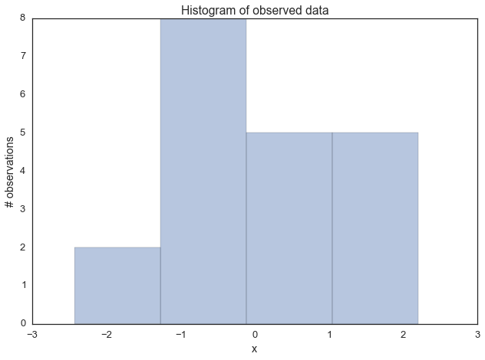
Next, we have to define our model. In this simple case, we will assume that this data is normal distributed, i.e. the likelihood of the model is normal. As you know, a normal distribution has two parameters -- mean μμ and standard deviation σσ. For simplicity, we'll assume we know that σ=1σ=1 and we'll want to infer the posterior for μμ. For each parameter we want to infer, we have to chose a prior. For simplicity, lets also assume a Normal distribution as a prior for μμ. Thus, in stats speak our model is:
μ∼Normal(0,1)x|μ∼Normal(x;μ,1)μ∼Normal(0,1)x|μ∼Normal(x;μ,1)
What is convenient, is that for this model, we actually can compute the posterior analytically. That's because for a normal likelihood with known standard deviation, the normal prior for mu is conjugate (conjugate here means that our posterior will follow the same distribution as the prior), so we know that our posterior for μμ is also normal. We can easily look up on wikipedia how we can compute the parameters of the posterior. For a mathemtical derivation of this, see here.
In [4]:
def calc_posterior_analytical(data, x, mu_0, sigma_0):
sigma = 1.
n = len(data)
mu_post = (mu_0 / sigma_0**2 + data.sum() / sigma**2) / (1. / sigma_0**2 + n / sigma**2)
sigma_post = (1. / sigma_0**2 + n / sigma**2)**-1
return norm(mu_post, np.sqrt(sigma_post)).pdf(x)

ax = plt.subplot()
x = np.linspace(-1, 1, 500)
posterior_analytical = calc_posterior_analytical(data, x, 0., 1.)
ax.plot(x, posterior_analytical)
ax.set(xlabel='mu', ylabel='belief', title='Analytical posterior');
sns.despine()
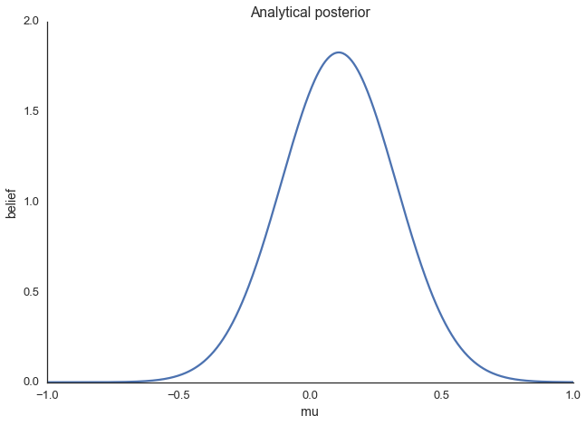
This shows our quantity of interest, the probability of μμ's values after having seen the data, taking our prior information into account. Lets assume, however, that our prior wasn't conjugate and we couldn't solve this by hand which is usually the case.

Explaining MCMC sampling with code
Now on to the sampling logic. At first, you find starting parameter position (can be randomly chosen), lets fix it arbitrarily to:
mu_current = 1.
Then, you propose to move (jump) from that position somewhere else (that's the Markov part). You can be very dumb or very sophisticated about how you come up with that proposal. The Metropolis sampler is very dumb and just takes a sample from a normal distribution (no relationship to the normal we assume for the model) centered around your current mu value (i.e. mu_current) with a certain standard deviation (proposal_width) that will determine how far you propose jumps (here we're use scipy.stats.norm):
proposal = norm(mu_current, proposal_width).rvs()
Next, you evaluate whether that's a good place to jump to or not. If the resulting normal distribution with that proposed mu explaines the data better than your old mu, you'll definitely want to go there. What does "explains the data better" mean? We quantify fit by computing the probability of the data, given the likelihood (normal) with the proposed parameter values (proposed mu and a fixed sigma = 1). This can easily be computed by calculating the probability for each data point using scipy.stats.normal(mu, sigma).pdf(data) and then multiplying the individual probabilities, i.e. compute the likelihood (usually you would use log probabilities but we omit this here):
likelihood_current = norm(mu_current, 1).pdf(data).prod()
likelihood_proposal = norm(mu_proposal, 1).pdf(data).prod()

# Compute prior probability of current and proposed mu
prior_current = norm(mu_prior_mu, mu_prior_sd).pdf(mu_current)
prior_proposal = norm(mu_prior_mu, mu_prior_sd).pdf(mu_proposal)

# Nominator of Bayes formula
p_current = likelihood_current * prior_current
p_proposal = likelihood_proposal * prior_proposal
Up until now, we essentially have a hill-climbing algorithm that would just propose movements into random directions and only accept a jump if the mu_proposal has higher likelihood than mu_current. Eventually we'll get to mu = 0 (or close to it) from where no more moves will be possible. However, we want to get a posterior so we'll also have to sometimes accept moves into the other direction. The key trick is by dividing the two probabilities,
p_accept = p_proposal / p_current
we get an acceptance probability. You can already see that if p_proposal is larger, that probability will be > 1 and we'll definitely accept. However, if p_current is larger, say twice as large, there'll be a 50% chance of moving there:
accept = np.random.rand() < p_accept

if accept:
# Update position
cur_pos = proposal
This simple procedure gives us samples from the posterior.

Why does this make sense?
Taking a step back, note that the above acceptance ratio is the reason this whole thing works out and we get around the integration. We can show this by computing the acceptance ratio over the normalized posterior and seeing how it's equivalent to the acceptance ratio of the unnormalized posterior (lets say μ0μ0 is our current position, and μμ is our proposal):
P(x|μ)P(μ)P(x)P(x|μ0)P(μ0)P(x)=P(x|μ)P(μ)P(x|μ0)P(μ0)P(x|μ)P(μ)P(x)P(x|μ0)P(μ0)P(x)=P(x|μ)P(μ)P(x|μ0)P(μ0)
In words, dividing the posterior of proposed parameter setting by the posterior of the current parameter setting, P(x)P(x) -- that nasty quantity we can't compute -- gets canceled out. So you can intuit that we're actually dividing the full posterior at one position by the full posterior at another position (no magic here). That way, we are visiting regions of high posterior probability relatively more often than those of low posterior probability.

Putting it all together
In [5]:
def sampler(data, samples=4, mu_init=.5, proposal_width=.5, plot=False, mu_prior_mu=0, mu_prior_sd=1.):
mu_current = mu_init
posterior = [mu_current]
for i in range(samples):
# suggest new position
mu_proposal = norm(mu_current, proposal_width).rvs()

# Compute likelihood by multiplying probabilities of each data point
likelihood_current = norm(mu_current, 1).pdf(data).prod()
likelihood_proposal = norm(mu_proposal, 1).pdf(data).prod()

# Compute prior probability of current and proposed mu
prior_current = norm(mu_prior_mu, mu_prior_sd).pdf(mu_current)
prior_proposal = norm(mu_prior_mu, mu_prior_sd).pdf(mu_proposal)

p_current = likelihood_current * prior_current
p_proposal = likelihood_proposal * prior_proposal

# Accept proposal?
p_accept = p_proposal / p_current

# Usually would include prior probability, which we neglect here for simplicity
accept = np.random.rand() < p_accept

if plot:
plot_proposal(mu_current, mu_proposal, mu_prior_mu, mu_prior_sd, data, accept, posterior, i)

if accept:
# Update position
mu_current = mu_proposal

posterior.append(mu_current)

return np.array(posterior)

# Function to display
def plot_proposal(mu_current, mu_proposal, mu_prior_mu, mu_prior_sd, data, accepted, trace, i):
from copy import copy
trace = copy(trace)
fig, (ax1, ax2, ax3, ax4) = plt.subplots(ncols=4, figsize=(16, 4))
fig.suptitle('Iteration %i' % (i + 1))
x = np.linspace(-3, 3, 5000)
color = 'g' if accepted else 'r'

# Plot prior
prior_current = norm(mu_prior_mu, mu_prior_sd).pdf(mu_current)
prior_proposal = norm(mu_prior_mu, mu_prior_sd).pdf(mu_proposal)
prior = norm(mu_prior_mu, mu_prior_sd).pdf(x)
ax1.plot(x, prior)
ax1.plot([mu_current] * 2, [0, prior_current], marker='o', color='b')
ax1.plot([mu_proposal] * 2, [0, prior_proposal], marker='o', color=color)
ax1.annotate("", xy=(mu_proposal, 0.2), xytext=(mu_current, 0.2),
arrowprops=dict(arrowstyle="->", lw=2.))
ax1.set(ylabel='Probability Density', title='current: prior(mu=%.2f) = %.2f\nproposal: prior(mu=%.2f) = %.2f' % (mu_current, prior_current, mu_proposal, prior_proposal))

# Likelihood
likelihood_current = norm(mu_current, 1).pdf(data).prod()
likelihood_proposal = norm(mu_proposal, 1).pdf(data).prod()
y = norm(loc=mu_proposal, scale=1).pdf(x)
sns.distplot(data, kde=False, norm_hist=True, ax=ax2)
ax2.plot(x, y, color=color)
ax2.axvline(mu_current, color='b', linestyle='--', label='mu_current')
ax2.axvline(mu_proposal, color=color, linestyle='--', label='mu_proposal')
#ax2.title('Proposal {}'.format('accepted' if accepted else 'rejected'))
ax2.annotate("", xy=(mu_proposal, 0.2), xytext=(mu_current, 0.2),
arrowprops=dict(arrowstyle="->", lw=2.))
ax2.set(title='likelihood(mu=%.2f) = %.2f\nlikelihood(mu=%.2f) = %.2f' % (mu_current, 1e14*likelihood_current, mu_proposal, 1e14*likelihood_proposal))

# Posterior
posterior_analytical = calc_posterior_analytical(data, x, mu_prior_mu, mu_prior_sd)
ax3.plot(x, posterior_analytical)
posterior_current = calc_posterior_analytical(data, mu_current, mu_prior_mu, mu_prior_sd)
posterior_proposal = calc_posterior_analytical(data, mu_proposal, mu_prior_mu, mu_prior_sd)
ax3.plot([mu_current] * 2, [0, posterior_current], marker='o', color='b')
ax3.plot([mu_proposal] * 2, [0, posterior_proposal], marker='o', color=color)
ax3.annotate("", xy=(mu_proposal, 0.2), xytext=(mu_current, 0.2),
arrowprops=dict(arrowstyle="->", lw=2.))
#x3.set(title=r'prior x likelihood $\propto$ posterior')
ax3.set(title='posterior(mu=%.2f) = %.5f\nposterior(mu=%.2f) = %.5f' % (mu_current, posterior_current, mu_proposal, posterior_proposal))

if accepted:
trace.append(mu_proposal)
else:
trace.append(mu_current)
ax4.plot(trace)
ax4.set(xlabel='iteration', ylabel='mu', title='trace')
plt.tight_layout()
#plt.legend()

Visualizing MCMC
To visualize the sampling, we'll create plots for some quantities that are computed. Each row below is a single iteration through our Metropolis sampler.
The first columns is our prior distribution -- what our belief about μμ is before seeing the data. You can see how the distribution is static and we only plug in our μμ proposals. The vertical lines represent our current μμ in blue and our proposed μμ in either red or green (rejected or accepted, respectively).
The 2nd column is our likelihood and what we are using to evaluate how good our model explains the data. You can see that the likelihood function changes in response to the proposed μμ. The blue histogram which is our data. The solid line in green or red is the likelihood with the currently proposed mu. Intuitively, the more overlap there is between likelihood and data, the better the model explains the data and the higher the resulting probability will be. The dotted line of the same color is the proposed mu and the dotted blue line is the current mu.
The 3rd column is our posterior distribution. Here I am displaying the normalized posterior but as we found out above, we can just multiply the prior value for the current and proposed μμ's by the likelihood value for the two μμ's to get the unnormalized posterior values (which we use for the actual computation), and divide one by the other to get our acceptance probability.
The 4th column is our trace (i.e. the posterior samples of μμ we're generating) where we store each sample irrespective of whether it was accepted or rejected (in which case the line just stays constant).
Note that we always move to relatively more likely μμ values (in terms of their posterior density), but only sometimes to relatively less likely μμ values, as can be seen in iteration 14 (the iteration number can be found at the top center of each row).
In [6]:
np.random.seed(123)
sampler(data, samples=8, mu_init=-1., plot=True);
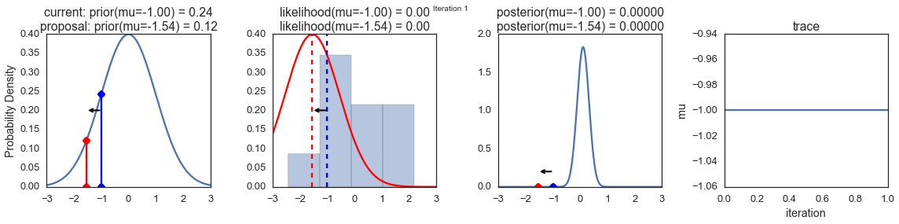
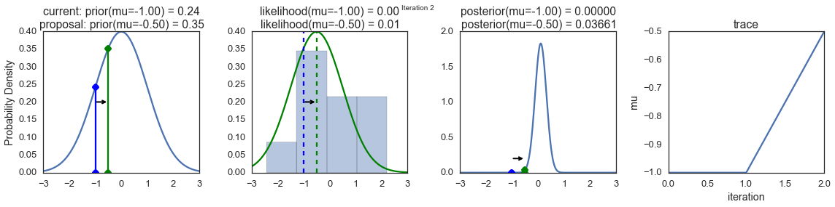
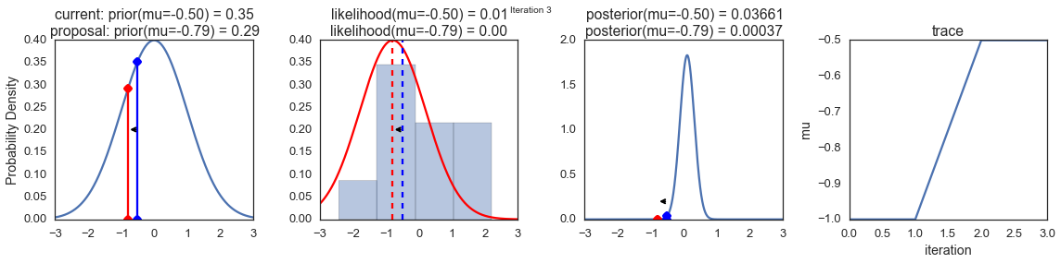
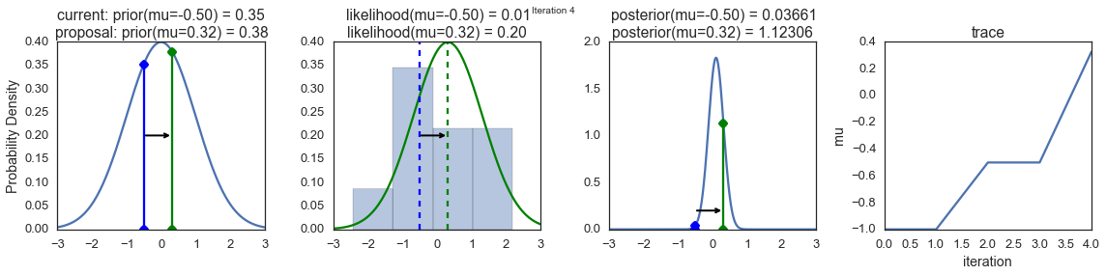
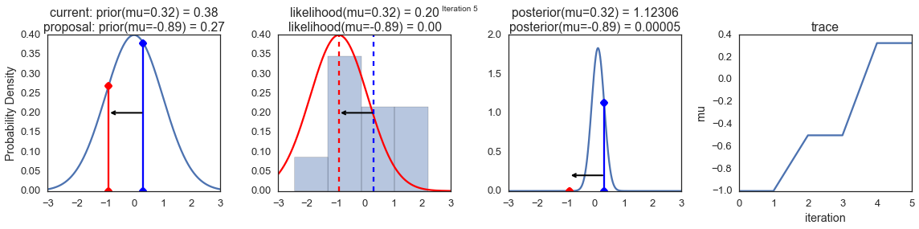
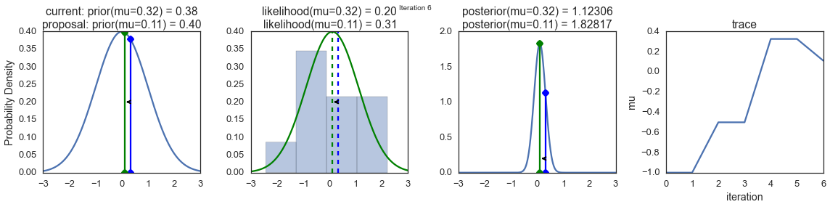
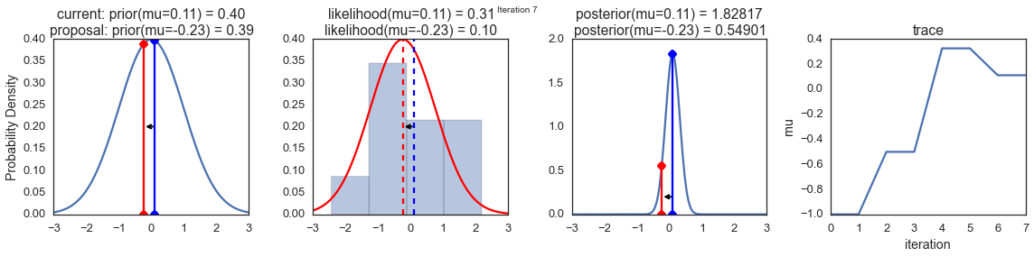
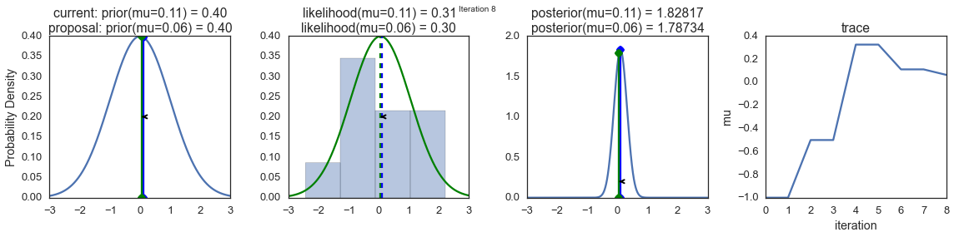
Now the magic of MCMC is that you just have to do that for a long time, and the samples that are generated in this way come from the posterior distribution of your model. There is a rigorous mathematical proof that guarantees this which I won't go into detail here.
To get a sense of what this produces, lets draw a lot of samples and plot them.
In [7]:
posterior = sampler(data, samples=15000, mu_init=1.)
fig, ax = plt.subplots()
ax.plot(posterior)
_ = ax.set(xlabel='sample', ylabel='mu');
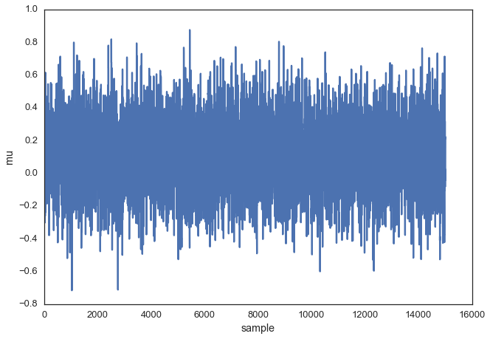
This is usually called the trace. To now get an approximation of the posterior (the reason why we're doing all this), we simply take the histogram of this trace. It's important to keep in mind that although this looks similar to the data we sampled above to fit the model, the two are completely separate. The below plot represents our belief in mu. In this case it just happens to also be normal but for a different model, it could have a completely different shape than the likelihood or prior.
In [8]:
ax = plt.subplot()

sns.distplot(posterior[500:], ax=ax, label='estimated posterior')
x = np.linspace(-.5, .5, 500)
post = calc_posterior_analytical(data, x, 0, 1)
ax.plot(x, post, 'g', label='analytic posterior')
_ = ax.set(xlabel='mu', ylabel='belief');
ax.legend();
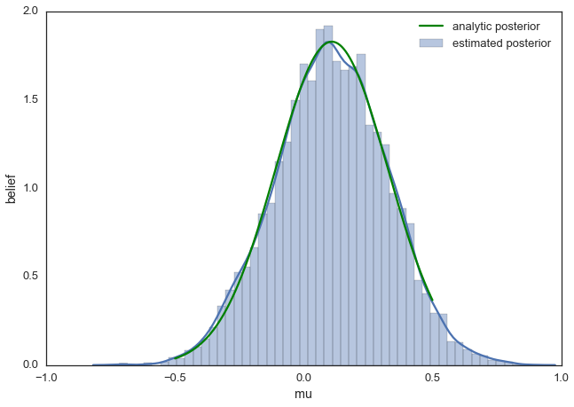
As you can see, by following the above procedure, we get samples from the same distribution as what we derived analytically.

Proposal width
Above we set the proposal width to 0.5. That turned out to be a pretty good value. In general you don't want the width to be too narrow because your sampling will be inefficient as it takes a long time to explore the whole parameter space and shows the typical random-walk behavior:
In [9]:
posterior_small = sampler(data, samples=5000, mu_init=1., proposal_width=.01)
fig, ax = plt.subplots()
ax.plot(posterior_small);
_ = ax.set(xlabel='sample', ylabel='mu');
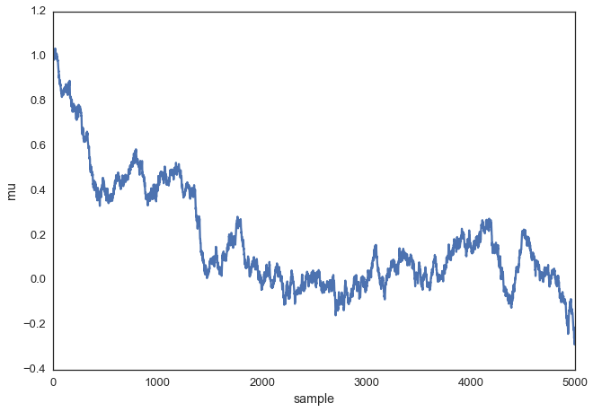
But you also don't want it to be so large that you never accept a jump:
In [10]:
posterior_large = sampler(data, samples=5000, mu_init=1., proposal_width=3.)
fig, ax = plt.subplots()
ax.plot(posterior_large); plt.xlabel('sample'); plt.ylabel('mu');
_ = ax.set(xlabel='sample', ylabel='mu');
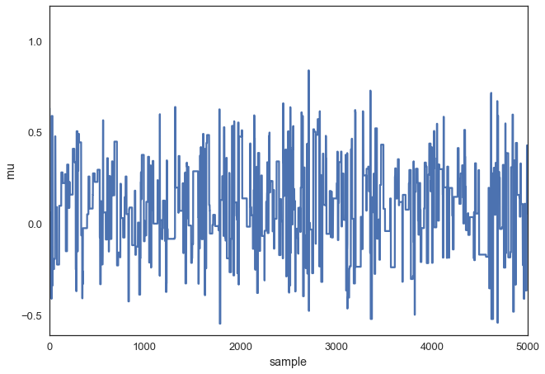
Note, however, that we are still sampling from our target posterior distribution here as guaranteed by the mathematical proof, just less efficiently:
In [11]:
sns.distplot(posterior_small[1000:], label='Small step size')
sns.distplot(posterior_large[1000:], label='Large step size');
_ = plt.legend();
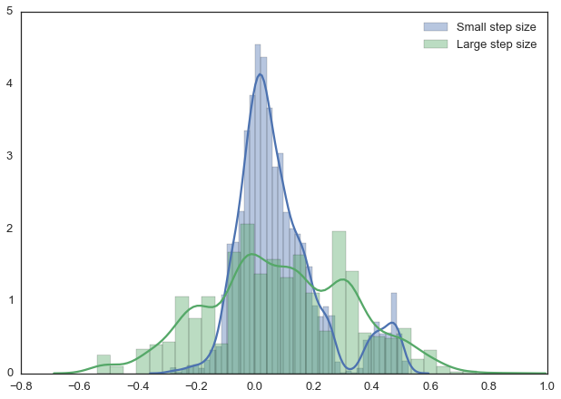
With more samples this will eventually look like the true posterior. The key is that we want our samples to be independent of each other which cleary isn't the case here. Thus, one common metric to evaluate the efficiency of our sampler is the autocorrelation -- i.e. how correlated a sample i is to sample i-1, i-2, etc:
In [12]:
from pymc3.stats import autocorr
lags = np.arange(1, 100)
fig, ax = plt.subplots()
ax.plot(lags, [autocorr(posterior_large, l) for l in lags], label='large step size')
ax.plot(lags, [autocorr(posterior_small, l) for l in lags], label='small step size')
ax.plot(lags, [autocorr(posterior, l) for l in lags], label='medium step size')
ax.legend(loc=0)
_ = ax.set(xlabel='lag', ylabel='autocorrelation', ylim=(-.1, 1))
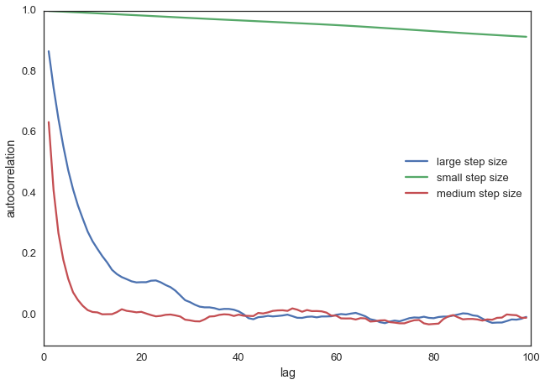
Obviously we want to have a smart way of figuring out the right step width automatically. One common method is to keep adjusting the proposal width so that roughly 50% proposals are rejected.

Extending to more complex models
Now you can easily imagine that we could also add a sigma parameter for the standard-deviation and follow the same procedure for this second parameter. In that case, we would be generating proposals for mu and sigma but the algorithm logic would be nearly identical. Or, we could have data from a very different distribution like a Binomial and still use the same algorithm and get the correct posterior. That's pretty cool and a huge benefit of probabilistic programming: Just define the model you want and let MCMC take care of the inference.
For example, the below model can be written in PyMC3 quite easily. Below we also use the Metropolis sampler (which automatically tunes the proposal width) and see that we get identical results. Feel free to play around with this and change the distributions. For more information, as well as more complex examples, see the PyMC3 documentation.
In [13]:
import pymc3 as pm

with pm.Model():
mu = pm.Normal('mu', 0, 1)
sigma = 1.
returns = pm.Normal('returns', mu=mu, sd=sigma, observed=data)

step = pm.Metropolis()
trace = pm.sample(15000, step)

sns.distplot(trace[2000:]['mu'], label='PyMC3 sampler');
sns.distplot(posterior[500:], label='Hand-written sampler');
plt.legend();
[-----------------100%-----------------] 15000 of 15000 complete in 1.7 sec
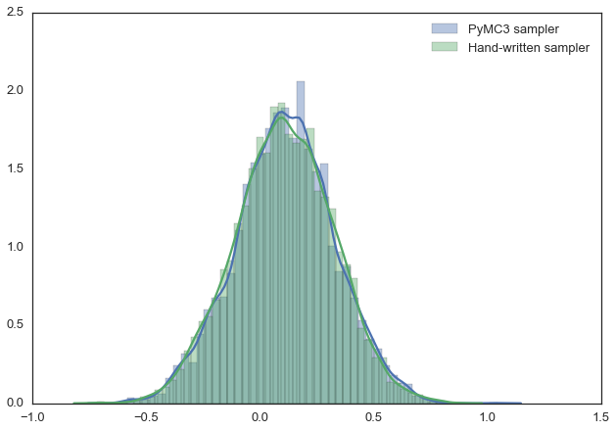
For now in this little
post I’m simply going to be satisfied with showing you how to use the
posterior function in the BayesFactor package to come up with a reasonable
and stable estimate.
Let’s set a random seed for reproducibility (on the chance you want your answer
to match mine else you’re likely to get a slightly different answer every time
because we are sampling). Use the posterior function and take a look at what we
get. Focus on the column labeled mu (the grand mean for all 3 runners),
and the columns labelled for each runner like runner-Usain Bolt which are
how their mean time differed from the overall mean mu. A negative in this
case indicates faster than the group mean. So we have 10,000 random simulations,
and for each one we have a simulated draw from our data.
set.seed(1234)
samples <- posterior(bf1, iterations = 10000)
head(samples)
## Markov Chain Monte Carlo (MCMC) output:
## Start = 1
## End = 7
## Thinning interval = 1
## mu runner-Usain Bolt runner-Asafa Powell runner-Yohan Blake
## [1,] 9.856853 0.05237562 -0.022243853 -0.03013176
## [2,] 9.936612 -0.02046742 -0.012416338 0.03288376
## [3,] 9.924282 -0.02070092 0.001488309 0.01921261
## [4,] 9.940220 -0.01911240 0.005561254 0.01355115
## [5,] 9.935515 -0.02139944 0.004691235 0.01670821
## [6,] 9.939779 -0.04707850 0.007379052 0.03969945
## [7,] 9.936617 -0.02555888 -0.004273167 0.02983205
## sig2 g_runner
## [1,] 0.023219831 0.2068197
## [2,] 0.009693205 0.3628194
## [3,] 0.010592488 0.2936392
## [4,] 0.008704533 0.1186418
## [5,] 0.009354557 0.6947791
## [6,] 0.011048214 0.5326179
## [7,] 0.008964808 3.0826286
To get our estimate of the posterior probability then given our data and our
model, all we have to do is count! What should we count? Well our hypothesis
H₁ is that when we look at timing Bolt < Powell < Blake. So let’s write
some r code to run through the 10,000 rows label each row TRUE if it supports
our H₁ and FALSE if it doesn’t. Then we can use sum to count the
“TRUES”. Once we have that count our posterior probability for our research
hypothesis becomes the number that support divided by the total number of tries
10,000.
consistent_with_h1 <- (samples[, "runner-Usain Bolt"] < samples[, "runner-Asafa Powell"]) &
(samples[, "runner-Asafa Powell"] < samples[, "runner-Yohan Blake"])
head(consistent_with_h1, 20)
## [1] FALSE TRUE TRUE TRUE TRUE TRUE TRUE TRUE TRUE FALSE TRUE
## [12] TRUE TRUE FALSE TRUE TRUE TRUE TRUE TRUE FALSE
N_consistent_with_h1 <- sum(consistent_with_h1)
N_consistent_with_h1
## [1] 8125
posterior_prob_h1 <- N_consistent_with_h1 / nrow(samples)
posterior_prob_h1
## [1] 0.8125
Now to calculate the Bayes Factor for this very specific and directional
hypothesis all we need do is divide our posterior probability (our probability
after seeing the data) by our prior prob which was our thing before we saw the
data. The larger the BF₁₀ the more the evidence is persuading us that our
model is “correct”.
bf__h1 <- posterior_prob_h1 / prior_odds_h1
bf__h1
## [1] 4.875
Using Kass and Raftery (1995) guidelines we have “Positive evidence”
Bayes factor value | Interpretation
1 – 3 | Negligible evidence
3 – 20 | Positive evidence
20 -150 | Strong evidence
>150 | Very strong evidence
It’s left to you to determine just how you feel about 5:1 odds. I suppose it
would depend on what the stakes were and how convinced you needed to be.

Just a little farther
Before I end this post I want to accomplish two more things that I will address
next post. The first is simply a way of encouraging you to make sure you
understand this methodology. When you look at the distribution of the data
plotted near the beginning of the post your eyes should “tell” you that while it
is pretty clear Bolt is fastest the difference between Powell and Blake is quite
small. Therefore the most likely reason we “only” get a BF of approximately 5:1
is the second part of our hypothesis Powell < Blake. So my challenge to you is
to take the code and change it to make your research hypothesis that Bolt <
Powell and that Bolt < Blake but make no assertion about Powell and Blake.
hint – pay attention to your prior too. My next post I’ll address this and
an even more complicated hypothesis.
Second, sometimes you want to compare nested models. If we think of the values
stored in bf1 as our “full model” i.e., is any runner faster than any other
runner in any direction we had a BF = ~7:1. Our more specific model gave us
~5:1. Bayes Factors are transitive and we can multiply them together to give us
a sense of improvement very easily…
## extract just the BF from bf1 so that we can multiply it
bf_full_model <- as.vector(bf1)
bf_full_model
## runner
## 7.089861
## Use transitivity to compute a comparative Bayes factor
bf_comparing <- bf__h1 * bf_full_model
bf_comparing
## runner
## 34.56307

Done
I want to end here today and follow up next week in an additional post. I hope
you’ve found this useful. I am always open to comments, corrections and
suggestions. Feel free to leave a comment in disqus or send me an email.

Conclusions
We glossed over a lot of detail which is certainly important but there are many other posts that deal with that. Here, we really wanted to communicate the idea of MCMC and the Metropolis sampler. Hopefully you will have gathered some intuition which will equip you to read one of the more technical introductions to this topic.

